**SMART FARMING USING IOT**

**SPRINT DELIVERY-4**

**TEAM ID:** **PNT2022TMID02308**

import time

import sys

import ibmiotf.application import ibmiotf.device

import random

organization = "157uf3" deviceType = "abcd" deviceId = "7654321" authMethod = "token" authToken = "87654321"

def myCommandCallback(cmd):

print("Command received: %s" % cmd.data['command']) status=cmd.data['command']

if status=="motoron":

print ("motor is on")

elif status == "motoroff":

print ("motor is off")

else :

print ("please send proper command")

except Exception as e:

print("Caught exception connecting device: %s" % str(e)) sys.exit()

# Connect and send a datapoint "hello" with value "world" into the cloud as an event of type "greeting" 10 times deviceCli.connect()

while True:

#Get Sensor Data from DHT11 temp=random.randint(90,110) Humid=random.randint(60,100) Mois=random. Randint(20,120)

data = { 'temp' : temp, 'Humid': Humid ,

‘Mois’: Mois

}

#print data def myOnPublishCallback():

print ("Published Temperature = %s C" % temp, "Humidity = %s %%" % Humid, “Moisture =%s deg c” % Mois “to IBM Watson")

success = deviceCli.publishEvent("IoTSensor", "json", data, qos=0, on_publish=myOnPublishCallback) if not success:

print("Not connected to IoTF") time.sleep(10)

deviceCli.commandCallback = myCommandCallback # Disconnect the device and application from the cloud deviceCli.disconnect()

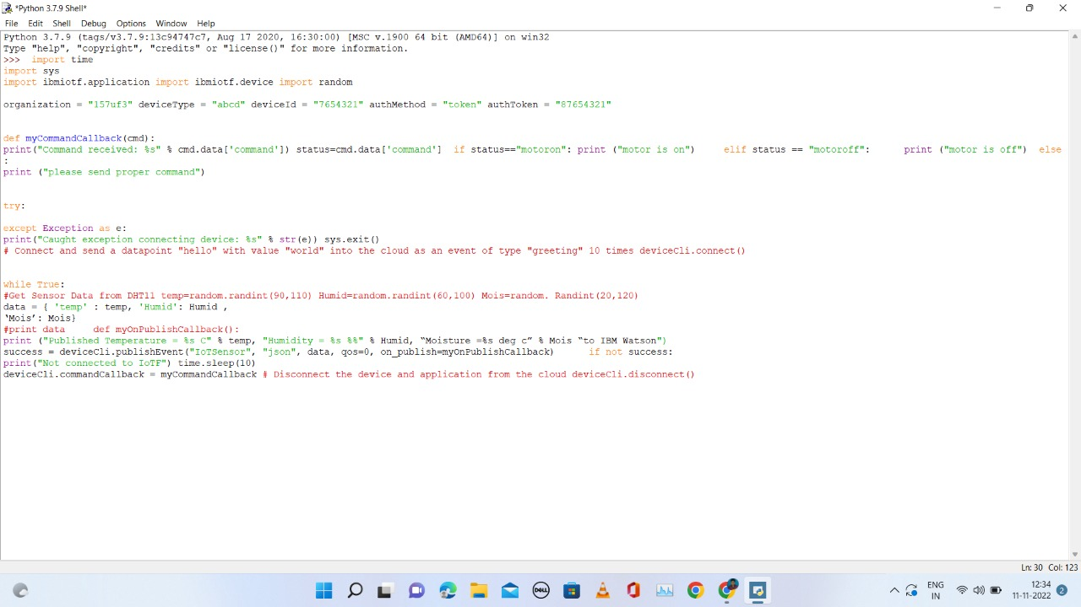

Python 3.7.0 (v3.7.0:lbf9cc5093, Jun 27 2018, 04:59:51) [MSC v.1914 64 bit (AMD6 ’ ’

4)] on win32

Type ’copyright’, "credits" or ’license() " for more information.

==--==== RESTART: C:\Users\ELCOT\Downloads\ibmiotpublishsubscribe.py ========

2022-11-07 20:01:24,074 ibmiotf.device.Client INFO Connected successfu -

lly: d:157uf3:abcd:7634321

Published Moisture = 90 deg C Temperature = 96 C Humidity = 76 % to IBM Uetxon Published Moisture - 103 deg C Tsmperaturs - 110 C Humidity - 68 % té IBM Uatmon Published Moisture = 45 deg C Temperature - 99 C Humidity - 100 % to IBM Watson Command received: motoron

motor is on

Published Moisture = 77 deg C Temperators = 91 C Humidity = 85 % to IBM Watson Published Moisture = 73 deg C Temperature - 94 C Humidity = 86 % to IBM Watson Command received: motoroff

aotor is off

Published Moisture = 101 deg C Temperature = 104 C Humidity = 87 % to IBM Uateon

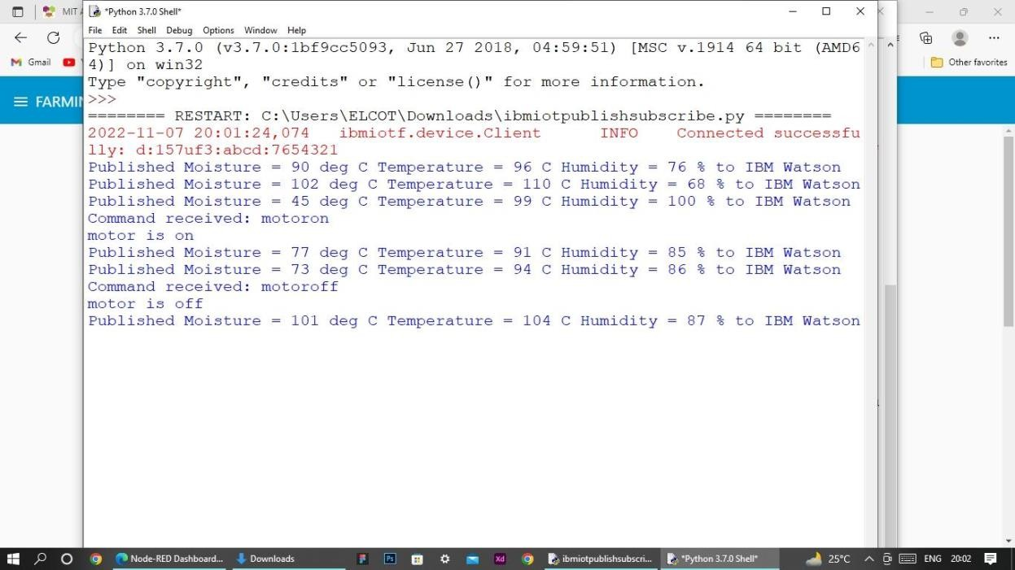

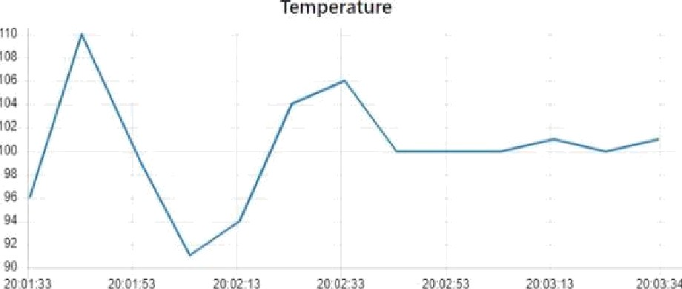

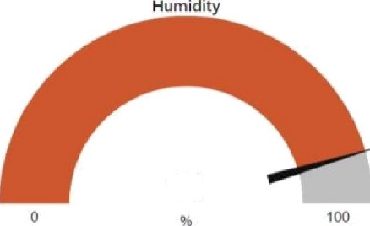

91

Moisture

